Item Automation & Developer Architecture

From Scripts, Workflows & Integrations to Financial Impact

Performance, Governance & Financial Integrity in NetSuite Automation
Understanding the Technical Backbone of ERP
Weekly Learning Series – Week 9

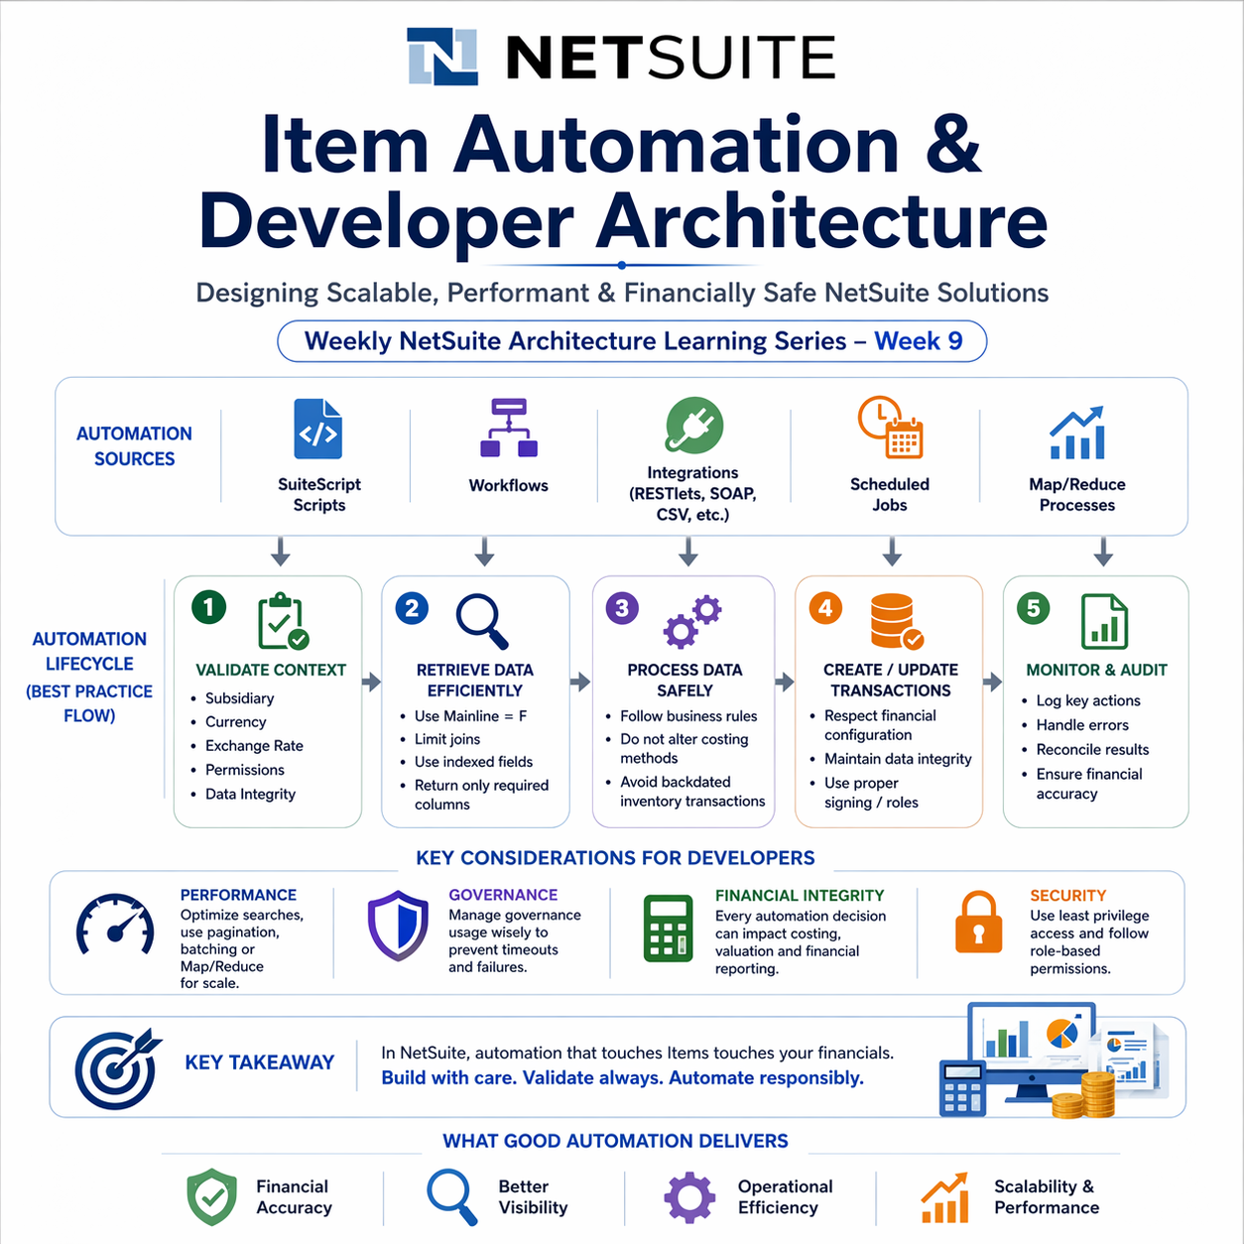

Introduction
- In modern Oracle NetSuite implementations, automation is deeply embedded across business processes through SuiteScript, workflows, integrations, and scheduled jobs.
- While automation improves efficiency and scalability, it also introduces a critical challenge:
- Not all automation is financially safe, especially when it interacts with Item records.
- This becomes especially important when automation interacts with Item records, which sit at the core of:
- Inventory valuation
- Cost accounting
- Revenue recognition
- Because Items directly influence how transactions are recorded in the General Ledger, even small automation mistakes can lead to:
- Financial inconsistencies
- Incorrect reporting outcomes
- System performance issues at scale
- As a result, developers must move beyond writing working scripts and start designing financially aware automation architectures.

Why Item Automation in NetSuite Is More Dangerous Than You Think
- In Oracle NetSuite, Item records are not just operational data.
- They directly control:
- Financial posting
- Inventory valuation
- Revenue recognition
- Which means: Every script touching Items is indirectly touching your financial statements.
- And yet, most automation is written like it’s just another record update. That’s where problems begin.
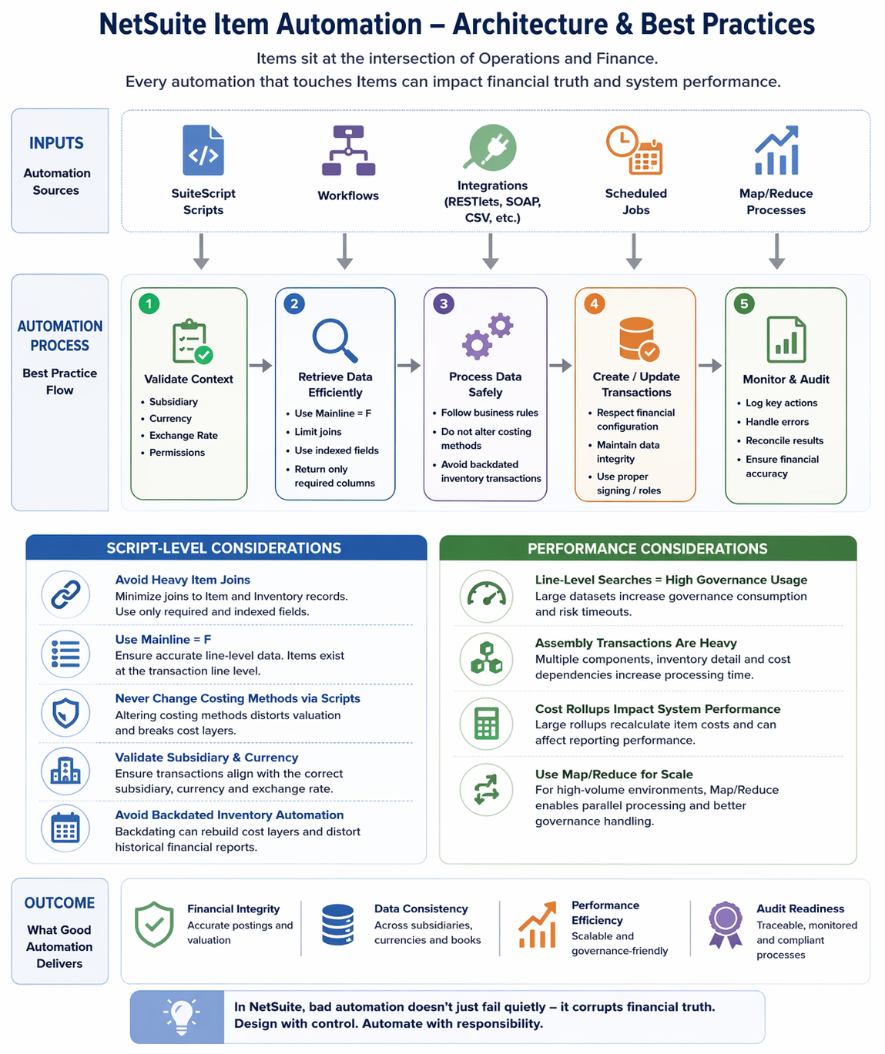

Script-Level Mistakes That Cause Real Damage
1. Heavy Item Joins Kill Performance
- Joins to Item and Inventory records increase complexity and slow execution.
- Better approach:
- Use only required fields
- Prefer indexed fields
- Avoid unnecessary joins

2. Ignoring Line-Level Data (Mainline = F)
- Items exist at the transaction line level, not the header.
- Without: Mainline = F
- You’re not even working with the real data.

3. Changing Costing Methods via Scripts
- Costing methods define how inventory is valued.
- Changing them programmatically can:
- Distort historical valuation
- Break cost layers
- Impact financial reporting
- This is not automation. This is financial corruption.

4. Skipping Subsidiary & Currency Validation
- In multi-entity setups, every transaction must align with:
- Subsidiary
- Currency
- Exchange rate
- Miss this, and your financial data stops making sense.

5. Backdated Inventory Automation
- Backdated transactions can:
- Rebuild cost layers
- Recalculate valuation
- Distort historical reports
- This is one of the fastest ways to break trust in reports.

Performance Reality (Where Scripts Collapse)
Line-Level Searches = Governance Burn
- Large datasets lead to:
- Script timeouts
- Governance exhaustion
- Solution:
- Pagination
- Batching
- Map/Reduce

Assembly Transactions Are Heavy
- More components = more processing = slower scripts.

Cost Rollups Impact Everything
- Large rollups:
- Recalculate inventory values
- Affect reporting performance
- Avoid triggering them blindly.

Map/Reduce Is Not Optional at Scale
- If you're processing large inventory data:
- Scheduled scripts will fail.
- Map/Reduce is the only scalable approach.

Summary & Key Takeaway
- Item records sit at the intersection of operations and finance in Oracle NetSuite.
- This means every automation touching Items is not just a technical operation.
- It directly influences how financial data is calculated, stored, and reported.
- To build reliable automation, developers must ensure:
- Financial configurations are respected
- Transaction context is always validated
- Solutions are designed to scale with data volume
- Because in NetSuite:
- Automation failures are not always visible.
- They don’t just break processes.
- They silently distort financial accuracy.

